
FACULTY

OF

ENGINEERING

AND

TECHNOLOGY

Department

of

Computer

Engineering
01
AI
0506

–

Design

and

Analysis

of

Algorithm

–

Lab

Manual

PRACTICAL-03
AIM: Implementation of max-heap sort algorithm.
1.) MAX HEAP
ALGORITHM:
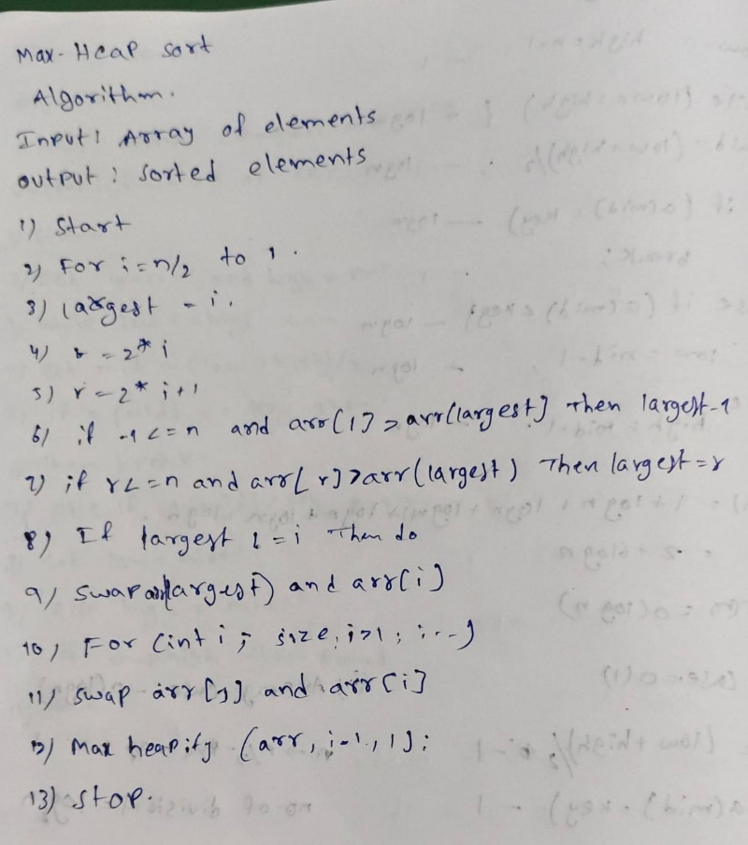

PROGRAM:
#include <iostream>
using namespace std;

void maxheapify(int arr[], int size, int i)
{
int largest = i;
int l = 2 * i;
int r = 2 * i + 1;

if (l <= size && arr[l] > arr[largest])
{
largest = l;
}

if (r <= size && arr[r] > arr[largest])
{
largest = r;
}

if (largest != i)
{
swap(arr[largest], arr[i]);
maxheapify(arr, size, largest);
}
}
void heapsort(int arr[], int size)
{
for (int i = size / 2; i >= 1; i--)
{
maxheapify(arr, size, i);
}
for (int i = size; i > 1; i--)
{
swap(arr[1], arr[i]);
maxheapify(arr, i - 1, 1);
}
}
int main()
{
int n;
cout << "Enter number of elements: ";
cin >> n;
int arr[n + 1];
cout << "Enter elements: ";
for (int i = 1; i <= n; i++)
{
cin >> arr[i];
}
heapsort(arr, n);
cout << "Sorted array: ";
for (int i = 1; i <= n; i++)
{
cout << arr[i] << " ";
}
return 0;
}

OUTPUT:
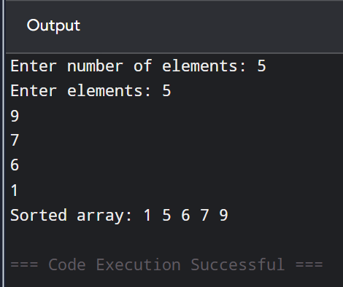

TIME COMPLEXITY:
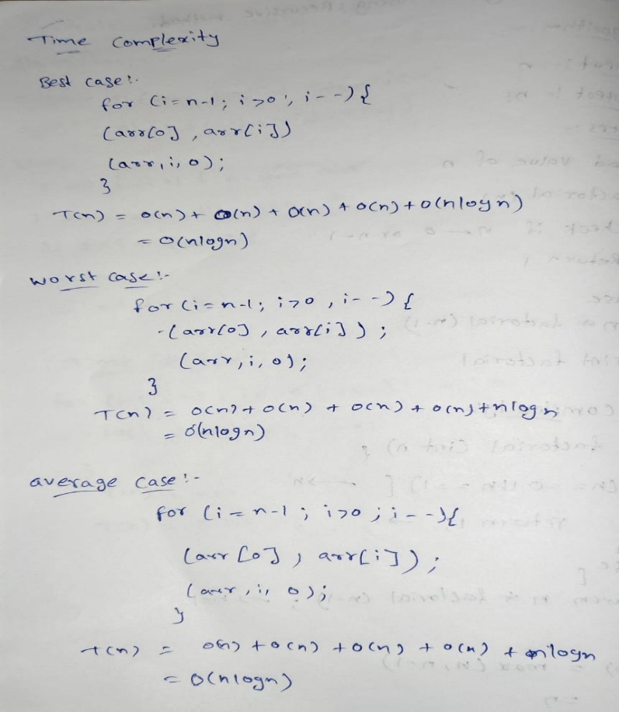
Conclusion:-
In conclusion, Max Heap Sort is an efficient comparison-based sorting algorithm that uses a max heap data structure to arrange elements in ascending order. It has a time complexity of O(n log n) in the best, average, and worst cases, making its performance predictable. It also requires only O(1) extra space when implemented in-place. Therefore, Max Heap Sort is useful when consistent performance and low extra memory usage are important.

